DESIGN RESEARCHERS IN RESIDENCE: MINERAL APPLICATION FORM 2025/26
Please complete the form below and return it, along with the required visual material, to mineral@designmuseum.org with the subject line ‘Mineral Application’. Please direct any queries about the application process or the Design Researchers in Residence programme to the same email address.
Deadline for entries is 12pm on Sunday 14 September 2025. Entries received after this deadline will not be accepted. Incomplete entries will not be considered.
Shortlisted applicants are required to attend an interview online during w/c 22 September 2025 and successful applicants will be informed w/c 29 September 2025.
Please refer to the accompanying documents; ‘Call for entries’ and ‘Terms and conditions’ on the Design Researchers in Residence webpage of the Design Museum or Future Observatory websites to ensure you fit the criteria for entry.

Please confirm you are resident and eligible to work in the UK:
Please note that this programme is only open to applicants who are resident and eligible to work in the UK. Documentary evidence will be requested.

ELIGIBILITY

Please note that this programme is only open to applicants who have:
- Completed an undergraduate degree in a relevant discipline within the last seven years (inclusive of the 2018/19 academic year or more recently).
Or
- Completed a postgraduate degree in a relevant discipline within the last five years (inclusive of the 2020/21 academic year or more recently).
Or
- Set up a design-related business within the last five years.
Current PhD students will have to demonstrate that they will suspend their studies for the duration of the Residency and that their supervisors approve of their application.
Please confirm that you are eligible to apply:
- PERSONAL INFORMATION
First name:
Surname:
Date of Birth:

PERSONAL DETAILS

CONTACT DETAILS
Street address:
City:
County:
Country:
Postcode:
Email address:
Please confirm email address:
Telephone number:

EDUCATION AND CAREER BACKGROUND

EDUCATION

Please give details of your academic background (most recent first):

Institution:
Course:
Graduation date [Month/Year]:

Institution:
Course:
Graduation date [Month/Year]:

Institution:
Course:
Graduation date [Month/Year]:

CURRENT AND PREVIOUS EMPLOYMENT

Please give details of your current/previous employment (most recent first):

Job title:
Description of duties:
Organisation:
Employment dates [Month/Year]:

Job title:
Description of duties:
Organisation:
Employment dates [Month/Year]:

Job title:
Description of duties:
Organisation:
Employment dates [Month/Year]:

Please list relevant work experience with most recent first:

Job title:
Description of duties:
Organisation:
Employment dates [Month/Year]:

Job title:
Description of duties:
Organisation:
Employment dates [Month/Year]:

EXAMPLES OF RECENT DESIGN OR RESEARCH WORK
Please attach two images showing examples of your recent design or research work, along with a short description about each piece. Images should be supplied as PDFs at a maximum size of 2MB each. Images should be titled with your surname plus the subtitle ‘recentwork1’ and ‘recentwork2’ e.g., surnamerecentwork1 and surnamerecentwork2.
Please note that examples must be of work that you have personally made or been responsible for making.

Please enter details for attached images below:
RECENT WORK 1
Title:
Medium:
Dimensions:
Date:
Description (max 100 words):

RECENT WORK 2

Title:
Medium:
Dimensions:
Date:
Description (max 100 words):

EXAMPLE OF WRITING
Please copy an exerpt of your writing here. This can be a thesis abstract, a published article or a description of a project you have worked on.

WRITING SAMPLE

Title:
Date:
Text (max 500 words):

Please provide any relevant links to online content featuring your work/practice (e.g. website or Instagram):

REFEREE (ACADEMIC REFEREE PREFERABLE BUT WORK REFEREE ACCEPTABLE TOO)
Please provide details of a related academic or work referee. References will only be requested for those designers shortlisted for interview.

Name of referee:
Job title:
Relationship to applicant:
Postal address:
Email address:
Telephone number:

DESIGN RESEARCHERS IN RESIDENCE: MINERAL
For the 2025/26 Design Researchers in Residence programme, the Design Museum and AHRC invite designers and researchers to respond to the theme of MINERAL.
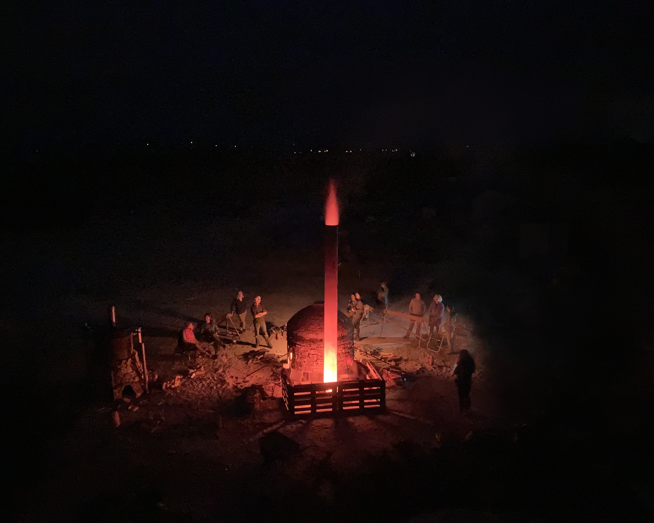
Brickfield Firing by Oliver Udy courtesy of Rosanna Martin
Minerals, concentrated in the Earth’s crust, are a finite resource.

Global demand for critical minerals is accelerating, particularly with the transition to renewable energy systems. The International Energy Agency estimates that by 2040 the demand for key minerals like lithium, cobalt and rare earth elements will be four times greater than today. These materials are integral to the manufacture of clean energy technologies, including wind turbines and electrical networks, which are central to the UK’s net zero goals

From kaolin pits in Cornwall to salt mines in North Yorkshire, the UK’s geological landscape is scarred by centuries of mineral extraction. These materials are not only held in geological strata, the mineral composition of soil and water plays a crucial role in supporting biodiversity and regulating ecological processes. Mineral fertilisers are used to provide plants with nutrients to grow. These delicate dynamics, often overlooked, are integral to the health of both natural and agricultural landscapes.

Simultaneously, there is a second mineral landscape in our urban environments: veins of ore embedded in discarded consumer electronics. Post-use materials represent a critical untapped resource.

Can net-zero goals be sustained through the continued extraction of finite mineral resources? How can design research better understand the UK’s dependence on these minerals?

We are currently seeking proposals for the next cohort of Design Researchers in Residence. This residency aims to support research that critically interrogates intersecting mineral landscapes in the UK – geological, ecological and urban – through case studies, field research and by building human and non-human relationships.

We are looking for practitioners working across industrial design, architecture, bio-design, systems design, policy research, material research, craft or graphic design. Projects may engage with a range of related themes, including but not limited to: mapping nutrient cycles and supply chains, mining ore streams, material science and the circular economy. We welcome applications that reflect on how we source, use, and repurpose minerals, and reckon with the full lifecycle of matter.

PROPOSAL
Please submit 150-200 words, as well as two images, explaining how you would respond to this theme. Your response should explain how you have interpreted the theme and give details of the design, construction, material and budget.
Describe what you want to do and how it fits in with your current work and future plans.
Please provide your 150-200 word response here:

PLEASE ENTER DETAILS FOR ATTACHED IMAGES BELOW
Images should be supplied as PDFs at a maximum size of 2MB each. Images should be titled with your surname plus the subtitle ‘image1’ and ‘image2’ e.g. surnameimage1 and surnameimage2.

RESPONSE TO THEME – IMAGE 1
Title:
Medium:
Dimensions:
Date:

RESPONSE TO THEME – IMAGE 2
Title:
Medium:
Dimensions:
Date:

SUPPORTING STATEMENT
Please submit up to 200 words explaining why you are applying for the residency.
This should include details of how you feel you would benefit from the programme, details of what you would do throughout the residency and how you would engage with the activities of the museum and the public throughout the process.
Important considerations before applying:
  - How will your previous research experience inform this project?
  - How will the residency benefit your creative practice and professional development?
  - What do you see as the personal outcome or progression of professional practice?
PLEASE PROVIDE YOUR 200-WORD RESPONSE HERE:

MENTORSHIP
Please provide details of a mentor whom you feel would be well-placed to guide the development of your project.
Name:
Job title:
How this person’s experience and knowledge support the development of your proposed research:

CLOSING INFORMATION
CHECKLIST
Have you completed this form in full?
Have you supplied and labelled the following attachments?
- surnamerecentwork1
- surnamerecentwork2
- surnameimage1
- surnameimage2

How did you hear about Design Researchers in Residence?

Word of mouth
Design Museum website
Other, please specify
By signing this form you agree to the terms and conditions of Design Researchers in Residence 2025/26.
Signature: Date:

